 | Tel: Home +2 088 2320665 -Hospital: +2 088 2413343 -Mobile +2 01225338766-Fax: +2 088 2333327 Email: abdelradimohamed@yahoo.com, abdelradimohamed@gmail.com
Assiut University Hospital
MOHAMED ABDELRADI ABDELSALAM FARGHLY MAHMOUD 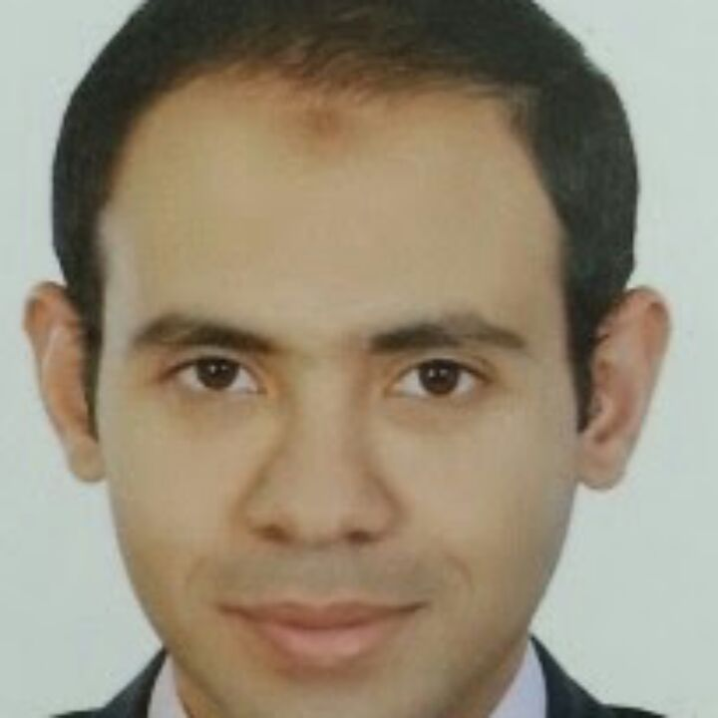
Personal data |  | \  First name : Mohamed  Middle names : Abdelradi Abdelsalam  Last name (Family or Surname): Mahmoud  Mobile : +2 01225338766  Email : abdelradimohamed@yahoo.com, abdelradimohamed@gmail.com  Date of birth : 10, December, 1985.  Nationality : Egyptian.  Address : Egypt, Assiut, Saudi buildings, building no.1.  Correspondence: Egypt, Assiut, Assiut University Hospital, Department of Orthopedic Surgery.  Current hospital: Department of Orthopedic Surgery, Assiut University Hospital, Assiut, Egypt.  Non-medical interests: Sports (Football) and reading novels.  Languages : Arabic, English and German (Basic).
Current position |  | Assistant lecturer of orthopedic Surgery, Assiut University Hospital, Assiut, Egypt (13/8/2014 till now).  Quality Assurance Co-ordinator of orthopedic surgery department : Assiut University Hospital (1/3/2013- until now)
Positions held |  | House officer: Assiut University Hospital (1/3/2009-28/2/2010).  Resident (Orthopedic Surgery): Assiut University Hospital (1/3/2010-28/2/2013).  Demonstrator (Orthopedic surgery ): Assiut University Hospital (1/3/2013-13/8/2014)
Qualifications |  | - High school diploma (basic education): Dar Hiraa High School, Assiut, Egypt (1999-9--2001).  -M.B.B.Ch: Faculty of medicine, Assiut University (9/2002-9/2008) (Excellent with honor).  - M.Sc. in Orthopedic Surgery: Assiut University Hospital (30/6/2013) in (Acromioclavicular injuries).  - Registration for Doctoral Degree (M.D) in Hip arthroscopic Surgery, Assiut University.
Memberships &Professional licensure | Egyptian Orthopaedic Association (EOA).  Egyptian Arthroscopy Association (EGAA).  AO (Arbeitsgemeinschaft für Osteosynthesefragen) Foundation.  SICOT (Société Internationale de Chirurgie Orthopédique et de Traumatologie).  Egyptian Ministry Of Health full registration number: 207115-2010/3/3.
Clinical Experience | During my work as a house officer, as a resident and as an assistant lecturer, I gained experience in performing the following activities:  - Minor surgical manoeuvres.  - Out-patient clinical management.  - In-patient clinical management.  - Trauma Surgery  -fixation of upper and lower extremity fractures  -correction of upper and lower extremity non-unions and mal-unions  -fixation of lumbar spine fractures  -fixation of some fractures of pelvic ring and acetabulum  - Shoulder Surgery  -mini-open cuff repair  -open biceps tenodesis  - arthroscopic SAD  - Elbow Surgery  - open tennis elbow release  - Wrist & Hand Surgery  -carpal tunnel release  -trigger finger release  -radial shortening for Keinbock's disease  -wrist fusion  - Hip Surgery  -proximal femoral osteotomies  -hip hemi-arthroplasty  -hip fusion  - Knee Surgery  -osteotomies around the knee  -knee fusion  -arthroscopic meniscectomy  -arthroscopic primary ACL reconstruction  - Ankle and Foot Surgery  -ankle , subtalar and triple arthrodesis  -diagnostic ankle arthroscopy  - Spine Surgery  - intertransverse lumbar fusion  -lumbar discectomy  -lumbar canal decompression

Graduate, post graduate training, courses and conferences attended | 2002-2008: Graduate studies; Faculty of medicine, Assiut University.  2008-2009: House officer; Assiut University Hospital.  2010-2013: Resident; Orthopedic Surgery Dept., Assiut University Hospital.  2009 : Attendance and organizing of "Operation Smile International Instructional Course  In Cleft lip & palate" as a volunteer, organized in Alexandria, Egypt in April 2009.  2009: Attendance and organizing of "Operation Smile mission "for (PALS/ ACLS ) as a volunteer , organized in Assiut University, Assiut , Egypt in December 2009  2009: Attendance of the course of “Emergency obstetric care ”, Assiut University, Assiut,  Egypt in August 2009.  2009: Attendance of the course of “Cardio-pulmonary resuscitation”,  Assiut University, Assiut, Egypt in August 2009.  2010: Attendance of the course of “International Computer Driving License ICDL”,  Assiut, Egypt in Feb. 2010.  2012: Attendance of 25th SICOT meeting in Dubai.  2013: Organization of Annual meeting of Egyptian Orthopedic Surgeons, Hurgada, Egypt.  2013: Attendance of Basic AO Trauma course, Cairo, Egypt.  2013: Attendance of the course of "University Administration" in June, 2013.  2013: Attendance of the course of "Research Ethics" in July, 2013.  2013: Attendance of the course of "International Publishing of Research" in July, 2013.  2013: Attendance of the course of “Communication Skills" in July, 2013.  2013: Attendance of the course of “Student Evaluation" in July 2013.  2013: Attendance of the course of “Conference Organization" in July, 2013.  2013: Attendance of Instruction Knee course, Cairo, Egypt.  2014: Organization of Assiut Hip Arthroscopy course, Assiut Egypt.  2014: Attendance of Advances AO Trauma course, Cairo, Egypt.  2014: Attendance of Instruction Shoulder course, Cairo, Egypt.  2014: Attendance of the 30th annual scientific conference" Role of the Faculty in Health Perform”, Faculty of medicine, Assiut University.  2014: Three months course in statistics (by SPSS program) and clinical research, organized by Public health dept., Faculty of medicine, Assiut University.  2014: Three months course in medical practice regulations and ethical codes  organized by department of forensic medicine and clinical toxicology, Faculty of medicine ,  Assiut University.

Teaching activities | Supervising house officers since March 2011.  Supervising the work of residents since March 2013.  Teaching experience for Medical student.
Research activities | Prevalence of osteoporotic fractures in upper Egypt.  Acromioclavicular injuries (Master Thesis).  Validation of hip scores.  Assessment of arthroscopic skills using training modules.
Referees  and references | [1] Assiut University was inaugurated in 1957 to encourage research, education and community services in Upper Egypt. It is located in Assiut City which is 375 Km south of Cairo, the capital. The university comprises sixteen faculties and two higher institutions. PO Code No. 71515, Egypt. http://www.aun.edu.eg  [2] Assiut University Hospital is one of the biggest University Hospitals in Egypt. It is the core referral center for the whole Upper Egypt that serves about twenty million people. The hospital contains 2027 beds, including 94 ICU beds, and 46 operative theaters in which 240 operations are performed daily. 1478 medical and 6428 paramedical staff serves in this hospital. 3000 patients visit the outpatient clinics and 1000 are received in the emergency departments daily. The department of Orthopedic Surgery contains 40 inpatients beds, 75 beds in Trauma and Emergency unit, Specialized arthroscopy theater, 3 major operation room, www.aun.edu.eg.  [3] Prof. Galal Zaky Said: Ex-Head of Orthopedic Surgery Dept., Assiut University – Egypt.  [4] Prof. Kamal El-Gaafary: Chief of Orthopedic Surgery Dept. – Assiut University  – Egypt.  [5] Prof. Hesham El-Kady: Orthopedic Surgery Dept. – Assiut University – Egypt.  [6] Prof. Hatem Galal: Orthopedic Surgery Dept., - Assiut University- Egypt.

